**PowerBI notes**

* **PowerBI** is a **Power Business Intelligence** and **PowerBI** was introduce by **Microsoft**





PowerBI logo

* **PowerB**I is one of best tool makes **Data Visualization, Dashboards and report**
* Data is collection of rows and columns , text , report etc…(Especially in PowerBI has Excel spreadsheet , texts , google sheets ,Sql and AWS or Azure
* PowerBI creates various business intelligence reports and its easy for business to spot trends, track performance and make data-driven decisions

What is Business intelligence?

* Its process of analyzing the business data and presenting user-friendly such as reports dashboard, chart , graphs
* Reports help the business owner to drive changes , eliminate , inefficiencies and adopt the market changes

**PowerBI** has three types of services

PowerBI has three special features involved its useful everyone

PowerBI desktop

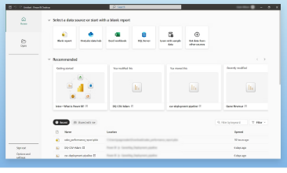

* Its used everywhere such collage students working professional and others
* Its is open source software

PowerBI services

* Its used as IT industry giving service employees
* Its service may be free of cost, sometimes paid (available)
* We can used practice purpose

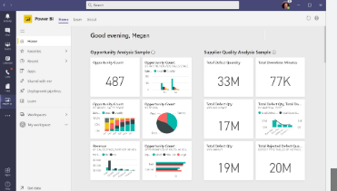

PowerBI mobile app

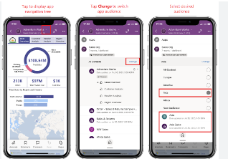

* We can download app for other benefits
* Mobile app supported less tools can be handled

Data Visualization (Three steps)

* Data loading (import data)
* Data cleaning, aggregate the data and format changes
* Make effective and meaningful data visualization

Power query

* It is used cleaning the data, aggregate functions , change Data format , Delete the null values and duplicate values

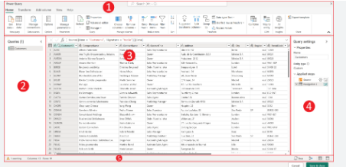

Data Modelling

* It’s used as interactive dashboards and its user – friendly
* Its make modelling format and easy to understand

PowerBI benefits

* **Data visualization**

Power BI allows users to create visual representations of data using charts, graphs, and maps.

* **Real-time analytics**

Power BI provides access to information in real-time, allowing users to prepare and measure data as soon as it enters the database.

* **Scalability**

Power BI can handle large amounts of data, making it scalable to meet increased demand.

* **Customization**

Power BI allows users to create customized dashboards and reports that can be tailored to their business needs.

* **Integration**

Power BI can integrate with Excel and other data sources.

* **Collaboration**

Power BI allows users to share their data with others, making it easy to collaborate on projects.

* **User-friendly**

Power BI is easy to use, with a drag-and-drop functionality for creating reports.

* **Cost-effective**

Power BI has a free desktop model, and the Pro and Premium models are priced based on the number of users and the size of the implementation.

* **In-demand skill**

Power BI skills are in demand, and can help users kickstart a new career.

Model View

Report View

* The primary interface where uses design their posts and dashboards

Data view

* Display the underlying data in tabular form allowing users to inspect and clean data

Model View

* Allows user to manage the relationship between datasets , create calculated columns and build the datasets